Press Release – HELAS.01.2006

CoRoT: Looking Deeper into the Stars.
The beginning of the journey.

27th of December - 14:23 UT. COROT will be launched from a Soyuz 2-1B, at the Baikonur Cosmodrome in Kazakhstan. This European space mission is expected to be at work for 3 years, during which it will search for new exoplanets and look deeper inside the stars.

To follow the launch go to http://www.cnes-tv.com/corot/

The CoRoT space mission

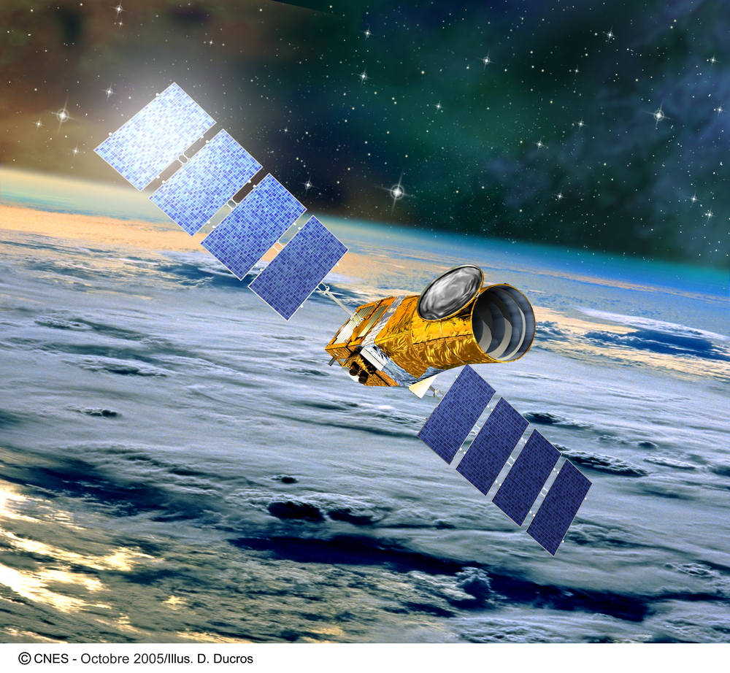

The CoRoT – Convection Rotation & planetary Transits - space telescope is an astronomy mission led by the French Centre National d’Etudes Spatiales (CNES) in association with a number of international partners including the European Space Agency (ESA).

The mission has two main scientific goals: the search for extrasolar planets, through the planetary transit method, and the study of stellar interiors and stellar evolution, through the analysis of stellar oscillations. These goals require an instrument capable of detecting tiny variations in the brightness of stars. To that end, the satellite carries a 27-cm afocal telescope equipped with a camera with 4 CCD detectors, and will observe 5 regions of the sky, each for 150 consecutive days. These observations will be complemented by a number of shorter observational sequences, lasting 20 days each, which aim to optimize the scientific return of the mission.

COROT Satellite Main Characteristics

Mass | 630 kg at launch
height | 4.1 m
Solar panels length | 9.6 m
Power | 530 W
Pointing accuracy | 0.5 arcsec
Orbit | polar
altitude | 896 km
Mission duration | 2.5 years

For more information see:

CoRoT@CNES - http://www.cnes-tv.com/corot/
CoRoT Science Community - http://corot.oamp.fr/
CoRoT@ESA - http://www.esa.int/esaCP/SEM4IKQJNVE_index_0.html

The asteroseismology program

By means of a technique known as Asteroseismology, astronomers believe that the pioneer space mission CoRoT will, for the first time, unveil the interior of stars other than our sun, and provide key information about the way they evolve, from the moment they are born to the end of their lives.

Stars can produce waves that resonate in their interiors. As a consequence, certain surface properties of stars – like brightness and velocity - can vary periodically in time. Just as in a musical instrument, the natural notes – or modes of oscillation – of a given star depend on the size and properties of the cavity in which the waves propagate. In a star this cavity is the interior of the star itself, or a fraction of it. Hence, through Asteroseismology – i.e. by studying the oscillations of stars - astronomers can probe stellar interiors. Since the interiors of stars are hidden from direct observation, stellar oscillations provide a unique tool to ‘look’ inside stars.

The study of oscillations in the Sun – i.e. Helioseismology – has proven extremely successful. Unfortunately the detection of tiny brightness variations is much harder in distant stars. For solar-like stars, the scintillation noise produced by the Earth’s atmosphere makes it impossible to detect the brightness variations from the ground. Even though larger brightness variations may be detected from the ground in more massive stars, the number of modes of oscillation detected in this way for such stars is in general insufficient to extract the desired information about their interiors.

Positioned above the Earth’s atmosphere, CoRoT will not only be able to detect brightness variations as small as those expected in solar-like stars, but will provide long, continuous observations of the same star. Long, uninterrupted observations of a star are necessary to characterize the modes in which the star oscillates – i.e. their periods (varying between 1 minute and 3 hours for CoRoT targets), amplitudes (as small as few parts per million), and life times (as short as a few days) – which, in turn, are needed for Asteroseismology. Even with networks of telescopes working under the best conditions, it would hardly be possible to acquire such long uninterrupted observations from the ground.

Two sub-programs will be carried out within the asteroseismic component of the space mission: the central program and the exploratory program. The central program will consist of observing the same field of view – and thus the same stars – for periods of 150 consecutive days. At least 5 such runs are expected, during which one main bright target and several fainter ones will be observed. These long runs will allow for the detailed study of about 50 stars which are chosen for their diagnostic potential. The exploratory program will consist on a number of smaller observation runs, lasting 20 consecutive days, during which several tens of stars with different masses, ages and chemical compositions will be observed, to cover the broader picture of stellar evolution.

Stars are one of the primary constituents of the Universe, and the only one providing the environment needed to produce most chemical elements that are known to exist. Understanding stars is also an essential step to understand phenomena that are directly related to them, such as the formation of planetary systems and the development of conditions such as those existing on Earth. By ‘looking’ inside stars, astronomers believe that CoRoT will teach us not only about the stars themselves, but also about the Universe as a whole.

The search for extrasolar planets program

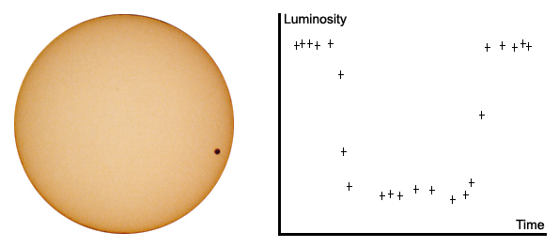

Through the observation of phenomena know as transits, astronomers believe that CoRoT will be able to discover a few dozen of telluric extrasolar planets – i.e. bodies with characteristics similar to those of the rocky planets existing in our own solar system, orbiting around stars other than the Sun.
The existence of planetary systems beyond our own has been repeatedly confirmed over the past decade. In fact, over 200 planets have already been discovered orbiting stars other than the Sun. The great majority of these planets are giant gas planets, similar to Jupiter in our solar system, many of them in very close orbits around their parent star and hence known as ‘hot Jupiters’. They have been detected through the effect they produce on the motion of the parent star. The detection of small rocky planets orbiting distant stars, on the other hand, remains extremely challenging.
The most promising method for detecting “small worlds” consists in looking for the drop in brightness observed when they pass in front of their parent star. Such a celestial alignment is known as a transit. From Earth, both Mercury and Venus occasionally pass across the disk of the Sun. When they do, they look like tiny black dots transiting the bright solar surface. Such transits block a tiny fraction of the parent star light. When a distant star is transited by the equivalent of Jupiter, about 1% of its light is blocked from view. In the case of a transit of an Earth-like planet, the attenuation in the star light would be only one part in ten thousand.
During the course of the mission, CoRoT will observe many thousands of stars in search for exo-planetary systems. Astronomers expect that a large number of giants (hot Jupiters), and a few dozen of smaller rocky planets will be discovered, leading to an unprecedented step in our understanding of the formation of planetary systems around distant stars.

Local involvement in the CoRoT mission

In order to explore efficiently the data from CoRoT it is necessary to ensure that the best and most adequate numerical models are available. Only with state-of-the-art stellar models and their oscillation frequencies will it be possible correctly to extract information from the data to be acquired by CoRoT.

To this end, it is of primary importance to optimise the tools available for Asteroseismology, both in what concerns numerical aspects of the codes, and the fundamental physical ingredients that are used to describe the stars and their oscillations. In order to ensure that the community has the necessary theoretical know-how to explore the data, the tools currently available will be extensively compared, improved, and adapted where necessary.

The CAUP seismology group is deeply involved in the development of tools for Asteroseismology. Our task in CoRoT is to coordinate the efforts of the CoRoT community in the development of evolution and seismic tools. The expertise of the group in CAUP is the use of seismic diagnostics to probe the interior of the star and the atmosphere from observational data such as those expected from CoRoT.

For more information please contact:
Mário João Monteiro
mjm@astro.up.pt
Phone: +351 - 226 089 830

CoRoT@CAUP - http://www.astro.up.pt

HELAS – European Helio- and Asteroseismology Network (www.helas-eu.org)

HELAS is a stroke of luck for helio- and asteroseismology in Europe. For the first time, a project devoted to the investigation of the solar interior and generally to the seismic probing of the structure of stars receives substantial funding from the European Commission for a period of four years (2006-2010). Based on this funding and the established work programme, HELAS offers a unique chance to advance helio- and asteroseismology further, and to proceed with the future steps in a well prepared manner. HELAS comes quite timely. Exciting projects and space missions are about to become operational, delivering overwhelming amounts of data about the Sun and the stars. Researchers in Europe must be in a position to process the data well prepared and with high efficiency.
Many researches in Europe will have the opportunity to exchange their knowledge and their experience within the frame offered by HELAS. They will be able to coordinate efforts and to share resources. We consider HELAS a unique opportunity for helio- and asteroseismology research groups all over Europe to achieve a leading position in stellar seismology.

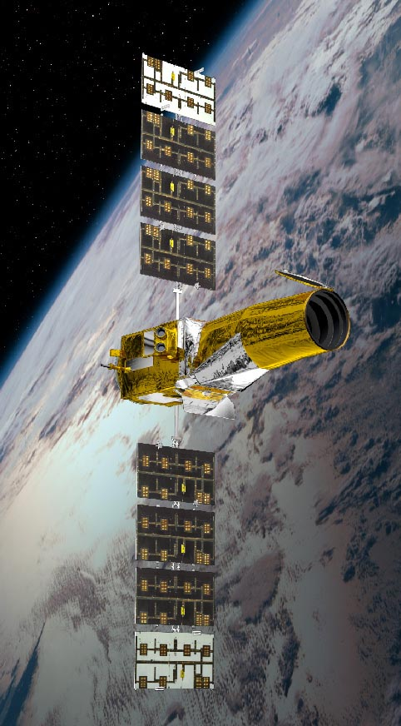
HELAS Contacts:

Germany
Oskar von der Lühe
ovdluhe@kis-freiburg.de
Laurent Gizon
gizon@mps.mpg.de

Spain
Pere L. Pallé
pere.l.palle@iac.es

U.K.
Michael J. Thompson Michael.Thompson@sheffield.ac.uk

Denmark
Jørgen Christensen-Dalsgaard
jcd@@phys.au.dk

Portugal
Mário João Monteiro
mjm@astro.up.pt

Italy
Maria Pia Di Mauro
mariapia.dimauro@iasf-roma.inaf.it

Belgium
Conny Aerts
conny@aster.kuleuven.be

Poland
Jadwiga Daszynska-Daszkiewicz
daszynska@astro.uni.wroc.pl
France
Thierry Corbard
thierry.corbard@obs-nice.fr

© cnes

